OPERATING SYSTEMS AND SYSTEMS PROGRAMMING

2520030159 – B.Hema Sri

PIPES CONCEPT:
1.
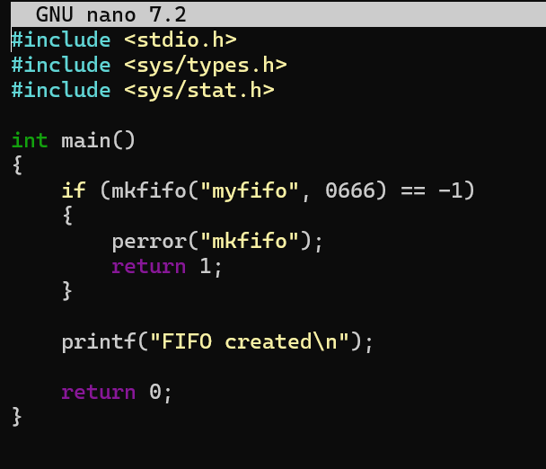
Output:
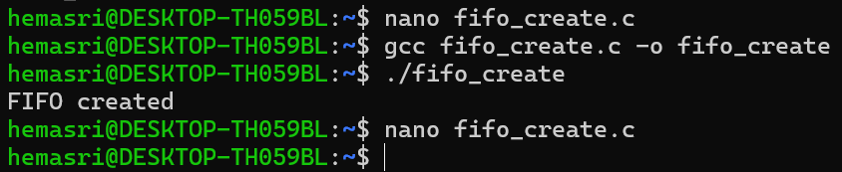

2.
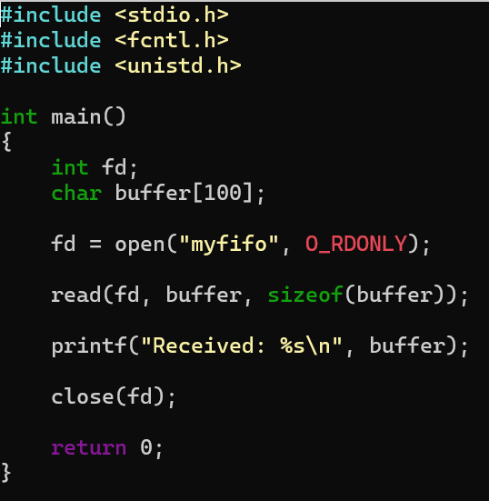
Output: 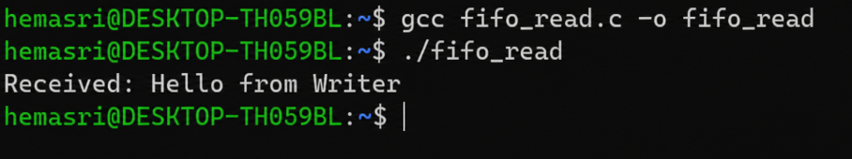

3.
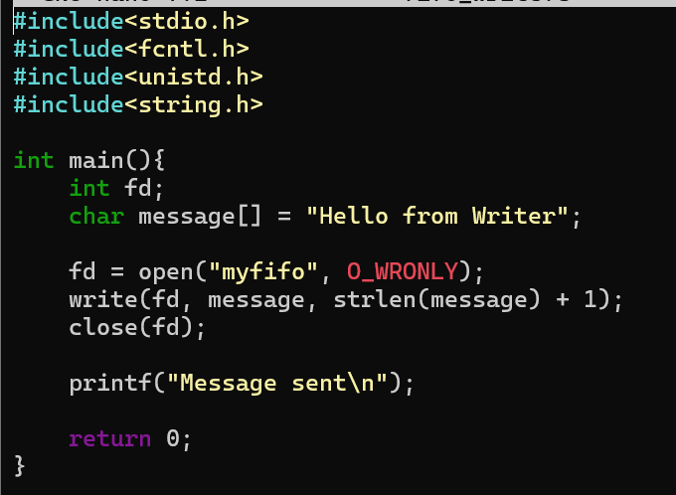
Output:
